Q. Use a 8 x 1 MUX to implement the logic function
Ans.
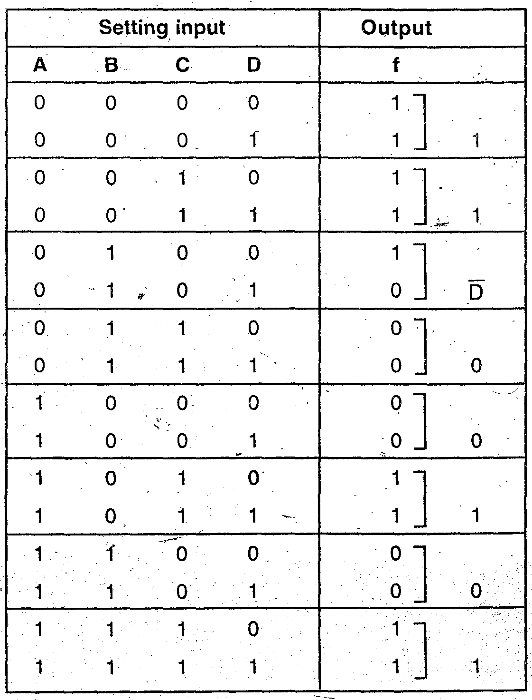

Now, again. Table
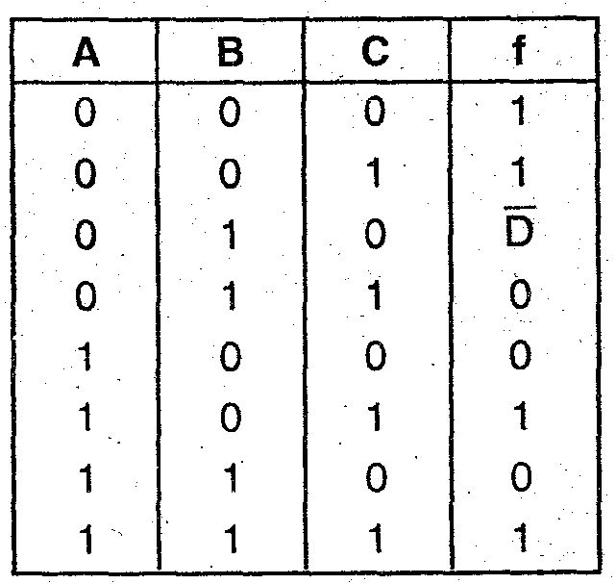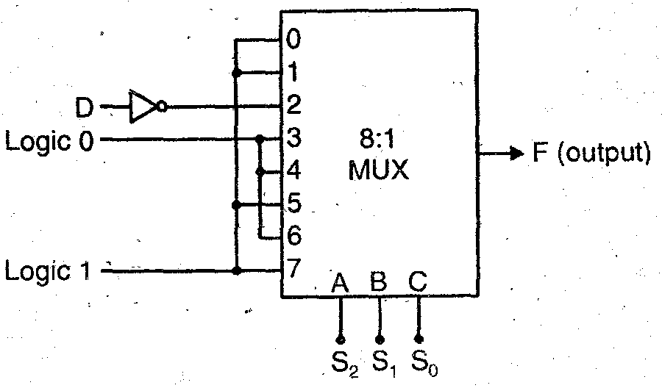

Q. Implement using 4 x 1 MUX
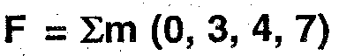
Ans.
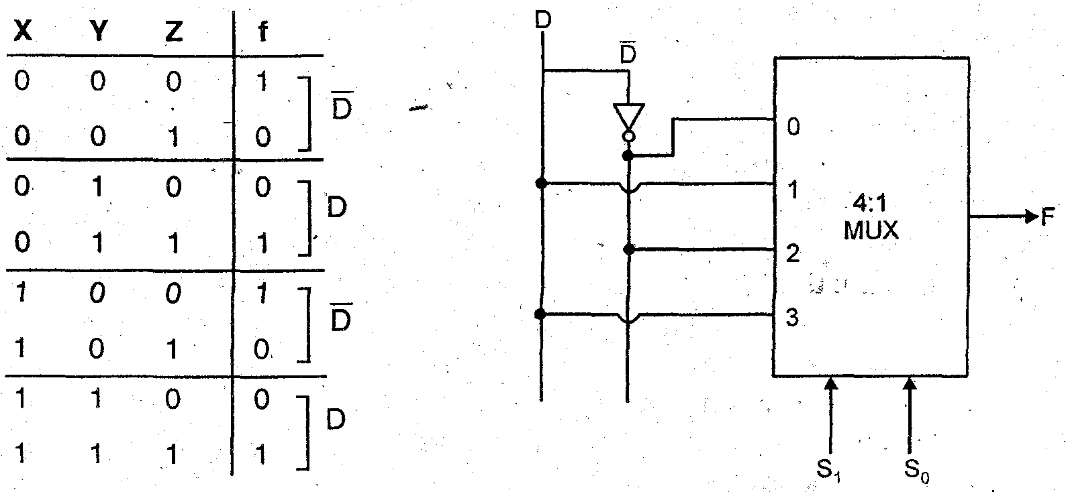

Q. Implement the following function using 3 to 8 decoder
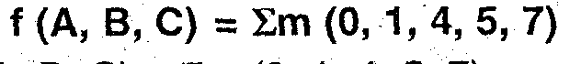
Ans.
Implementation using 3 to 8 decoder:
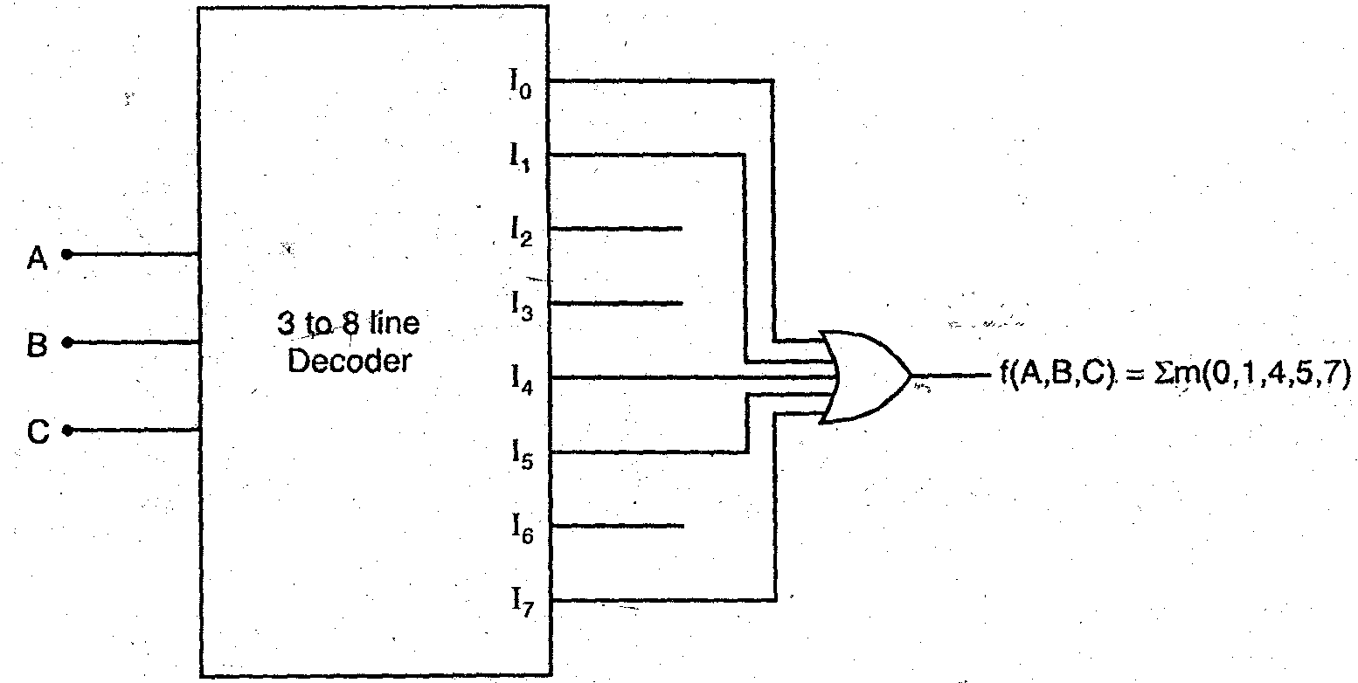

Q.Define a demultiplexer. Show how to convert a decoder into a demultiplexer. Indicate how to add a strobe to this system.

Ans. Demultiplexer: Demultiplexer is a device which has single input line and many i.e. 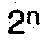 output lines The relation of specific output line is controlled by the value of n’ selection lines It performs the inverse operation of multiplexer

In case of decoder, it has n input lines and unique output lines. Let us take an example of 2 to 4 line decoder to convert the decoder into a demultiplexer.

2 to 4 line Decoder:
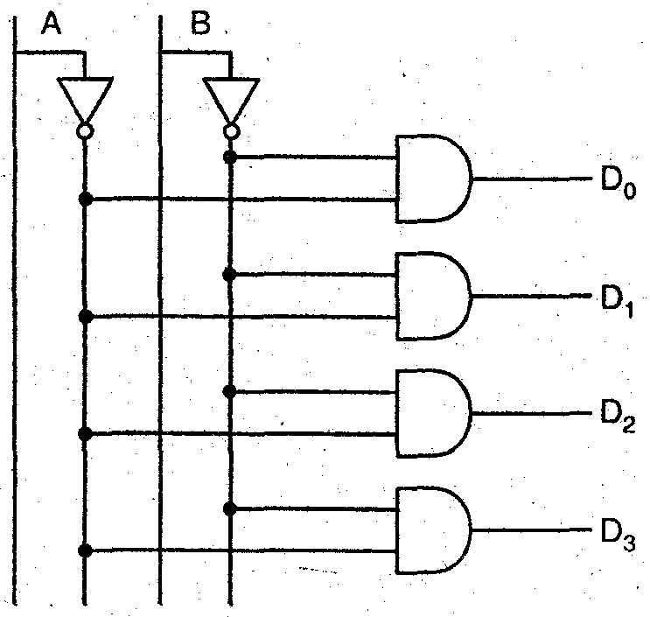

It can be converted into demultiplexer if D1 i e data Input line is converted to all the AND gates simultaneously.
Stroke signal is also added to all the AND gates simultaneously as shown in fig.
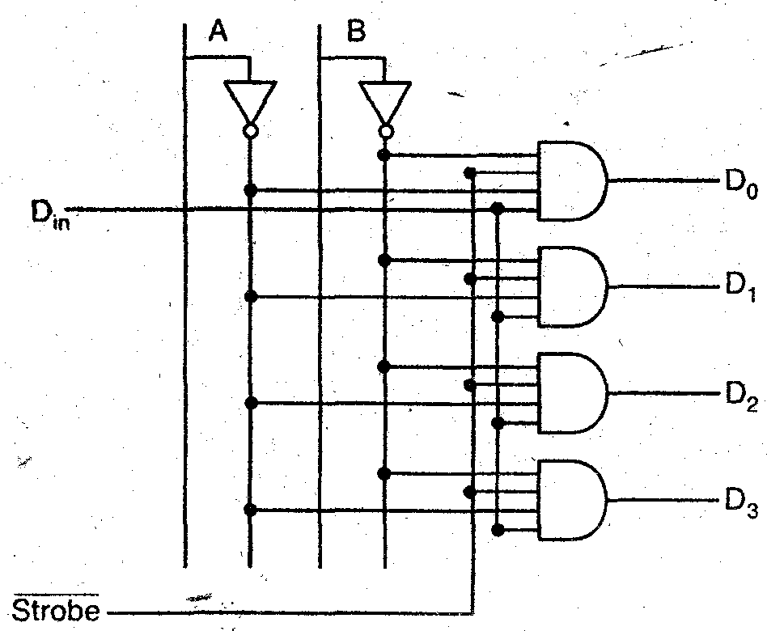
Strobe signal is similar to enable signal for chip selection. It is an active low signal. If high signal is applied to stroke the chip will be disable because i = 0 goes to all the AND gates And we receive no output at D0, D1, D2 and D3
Q. Explain the difference between DMUX and MUX
Ans. Difference between DMUX and MUX:
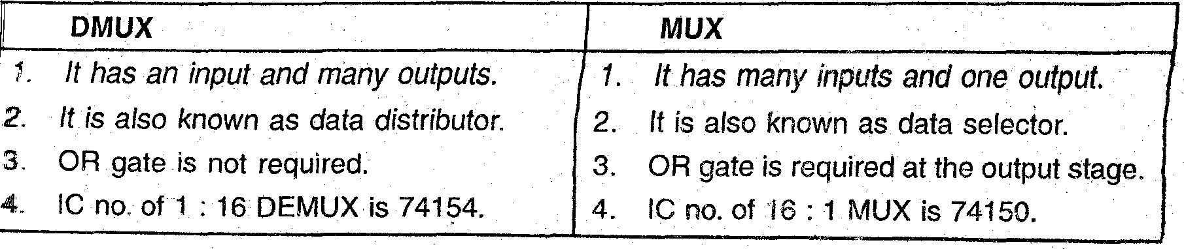
Q . Write short note on BCD display drive.
Ans. BCD display drive These are used to display BCD codes. BCD to seven segment decoder accepts the BCD code and provide output to energize seven segment display devices in order to produce a decimal read out. In BCD drive each segment is made up of such material that it emits light when current is passed through it.
BCD to seven segment decoder: Let us consider it for common cathode display. Truth table is as shown:
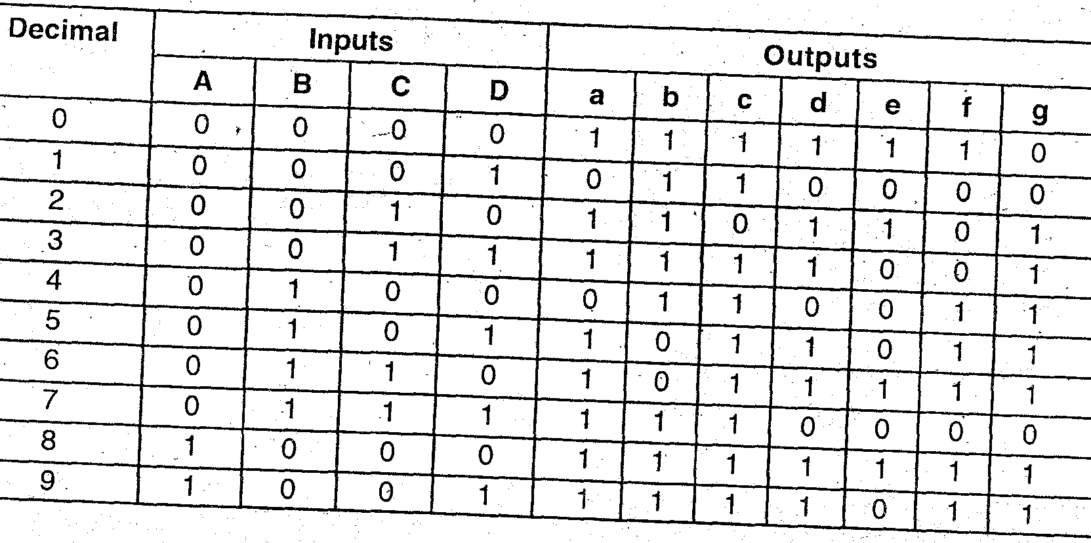
Put rest of the combinations as don’t care i e 10, 11, 12,13, 14 and 15 decimal are taken as ‘X’.
K maps are as shown for designing:
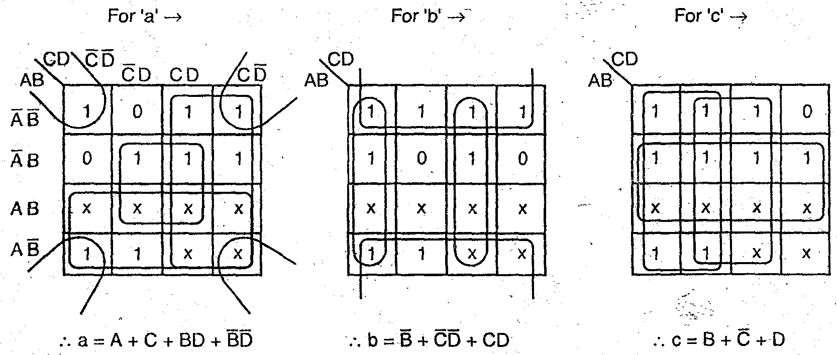
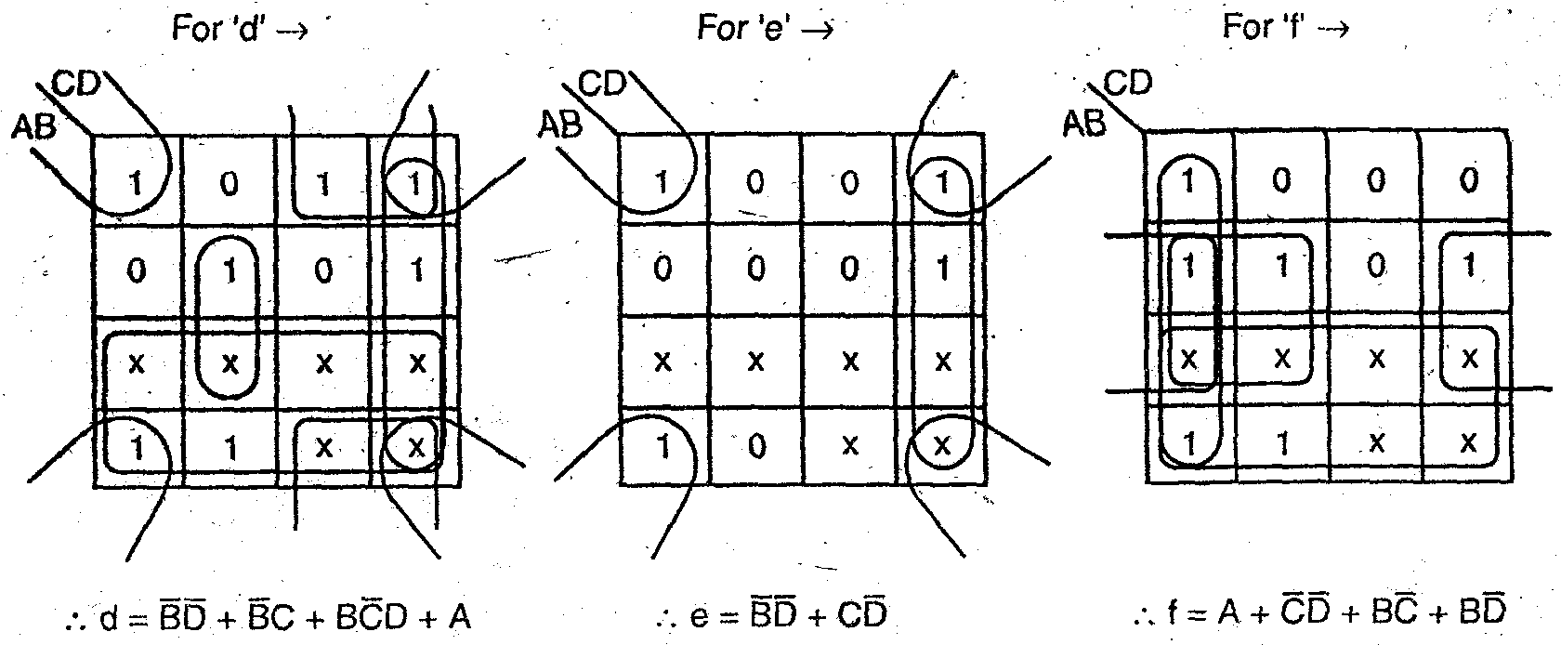
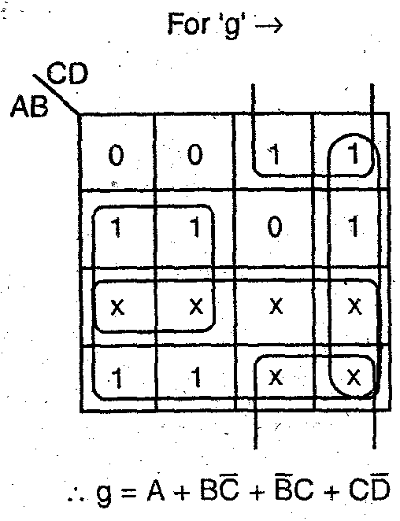
Its circuit diagram is as shown:
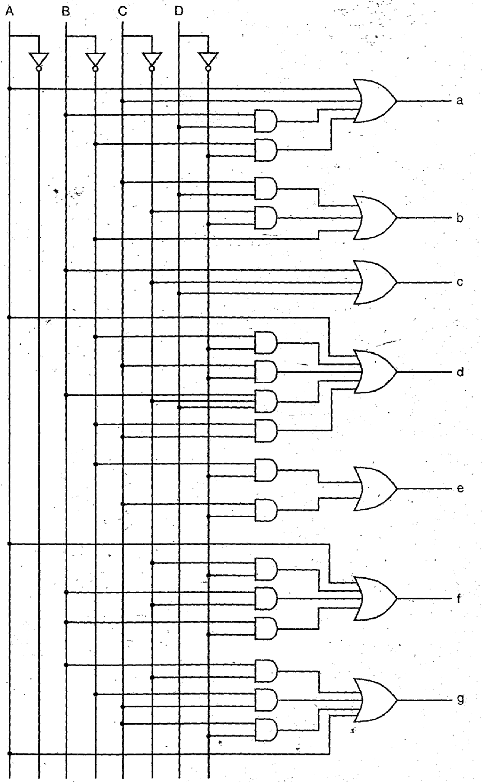
Figure shows the BCD to seven segment decoder for a common cathode type display.

Memory
Remember These:
- Memory is used for storing binary words.
- Memory size is specified by the number of words i.e. ‘M’ and the number of bits per word i.e. ‘N’, such as : M x N.
- Reading is the process by which the data can be retrieved from memory:
- Writing is the process by which the data can be stored in the memory.
- Semiconductor memories make use of bipolar and MOS.
- Types of memories -
(a) RAM
(b) ROM
(c) CAM
- RAM is the random access memory or read/write memory. One can read and write in RAM.
- ROM is the read only memory. One can only read from ROM nothing can be written in it.
- RAM is of two types:
(a) SRAM
(b) DRAM
- SRAM is also known as static RAM. In SRAM data will remain stored permanently as long as power is supplied, they need not required rewriting periodically the data. The basic cell is SRAM is a flip-flop.
- DRAM is also known as dynamic RAM. In DRAM rewriting periodically the data into memory is required. The basic cell in DRAM is a capacitor.

- ROM is of four types:
(a) Masked ROM
(b) PROM
(c) EPROM
(d) EEPROM
In masked ROM the data is stored permanently through photomasking during fabrication i.e. programming is done through masking and metalization process.
- PROM is the programmable read only memory. it is programmed using PROM-programmer and once the data is programmed (i.e. written) cannot be rewrite or changed again.
- EPROM is the erasable programmable read only memory. The user can erase and programme this memory again and again. The EPROM is erased by exposing the chip from inside via window at the top to ultra violet light.
- EEPROM is the electrically erasable. programmable read only memory. its function is similar to EPROM but instead UV light the data can be erased using electrical signals. PLAs are programmable logic arrays in which AND-OR gate arrays are used and programmed for specific logic functions.

- PLDs are the programmable logic devices. There are of three types
(a) PAL
(b) PLA
(c) PGA or FPGA.
- PAL are the programmable arary logic in which AND gate arrays are programmable and OR gate arrays are fixed.
- FPGA is the field programmable gate array. It consists of logic blocks i.e. an array of circuit elements.
- CAM is the content addressable memory and is a special type of RAM which can be accessed by searching for data content.
- CAM can perform read, write and associate operations.
CCD is a charge coupled device memory which make use of MOS as a capacitor to shift and store digital information. MOS capacitor acts as a dynamic shift register.
Q. Explain the Bipolar RAM Cell.
Ans. Bipolar transistor is used in bipolar ROM cell. It is as shown in figure.
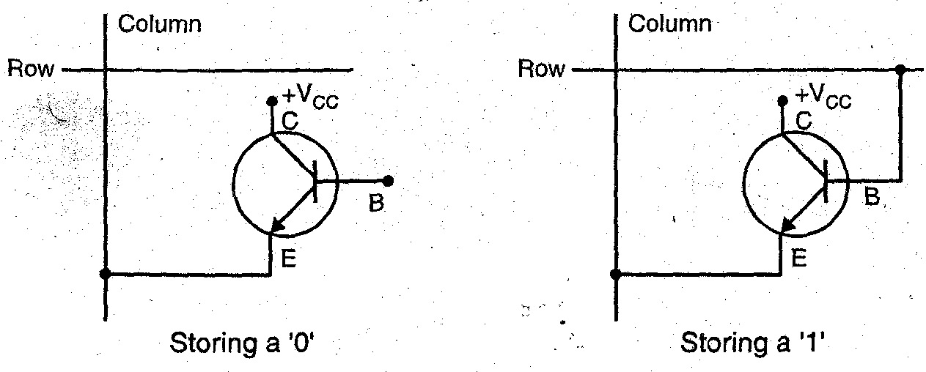
When base of transistor is not connected with a row no current flows to the base and it represents a storage of logic ‘0’. On the other hand, when base is connected the flowing to the base of transistor and it represents a storage of logic ‘1’.
Q . What is a non-volatile memory?
Ans. Non-volatile memory: The memory in which the data stored or information
present once does not change even after the power is switched off is called as non-volatile memory.
ROM i.e. Read only memory is the example of non-volatile memory. Because such memories hold the data or information even if power is switched off.
Q. What are the advantages of static RAM over Dynamic RAM?
Ans. Advantages of static RAM over Dynamic RAM:
1. Access time of SRAM is less and thus these memories are faster memories.
2. As SRAM is consists of flip-flops thus, refreshing is not required.
3. Less number of memory cells are required in SRAM for unit area.
Q. A certain memory stores 8 k x 16 bit words. How many data input lines, data output lines and address lines does it have ? What is its capacity in bytes?
Ans. Memory is M x N form where M are memory locations and N are data input lines. Here , M = 8K and N = 16
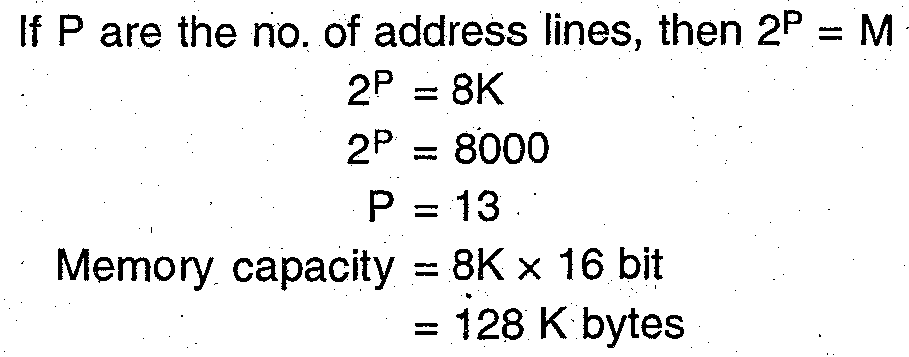
Q. What is the difference between static and dynamic RAM?
Ans.
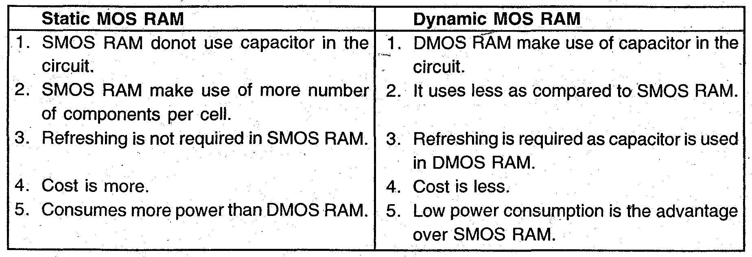
Q. What is EEPROM?
Ans. EEPROM : Electrically Erasable PROM or Electrically Erasable Programmable Read Only Memory. This memory stores a bit by charging the floating gate of an FET. Thus, the memory is similar to EPROM except that the information can be altered by using electrical signals at the register level rather than erasing all the information i.e. It can be erased information byte to byte.
Q. What is cache memory?
Ans. Cache memory is a type of semiconductor memory. It forced its entry as fast memory device. It works as an interface between the CPU and the primary memory. Following block diagram shows the position of cache memory:
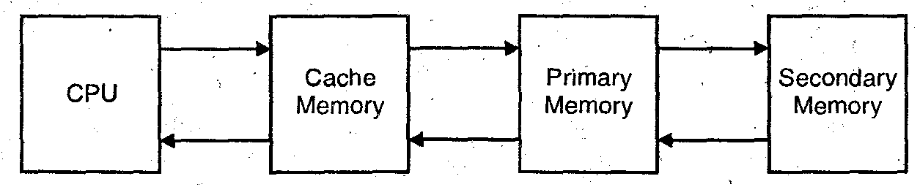

Q . Design the OR Matrix or OR array.
Ans. These gives the logical sum terms of output from AND arrays as shown in fig.
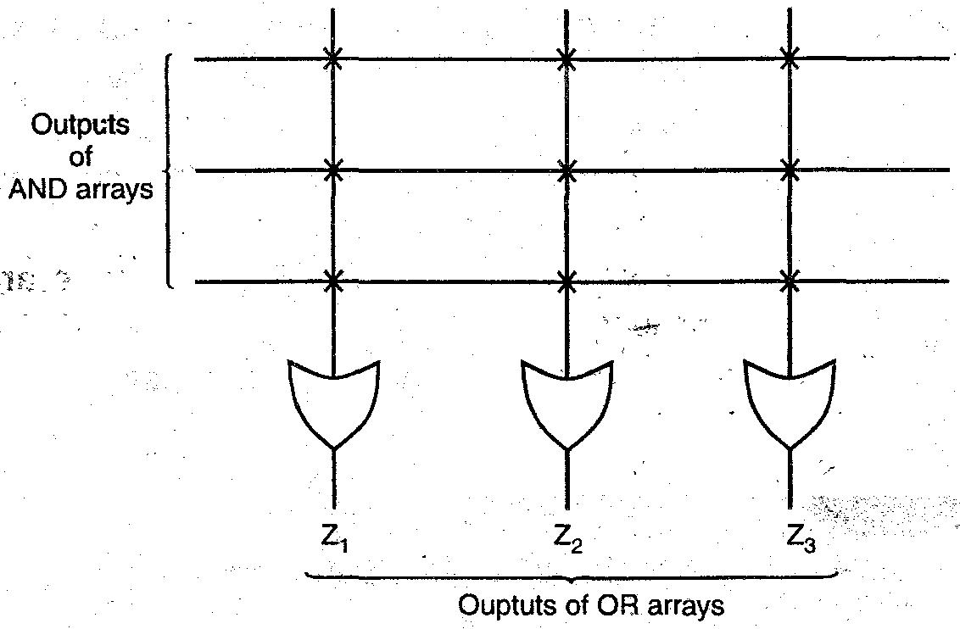

OR arrays gives sum terms in the logical form. Such as:
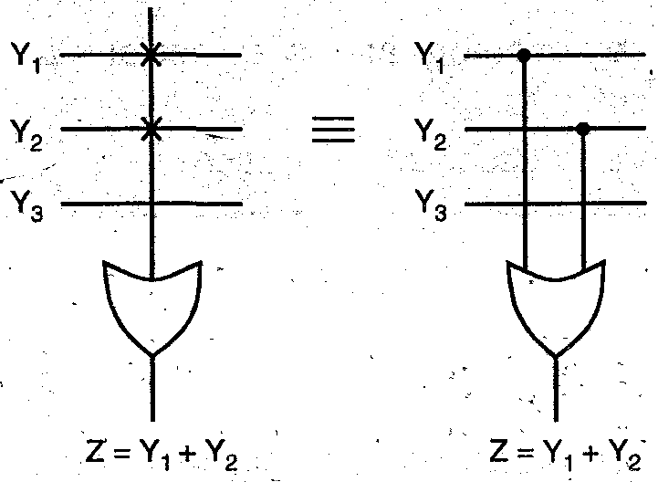
Here ‘X’ are the fuse links used in diagrams. The interconnections without ‘X’ are unplugged fuses or blown off fuse links.
Q. What do you mean by PLD’s?
Ans. PLDs: Programmable logic devices are the special type of IC’s used by the user and are programmed before use Different type of logic functions can be implemented using a single programmed IC chip of PLD’s. PLD s can be reprogrammed because these are based on re-writable memory technologies Fuse links are used to programmed the PLD b the user according to the type of PLD to be manufactured.

Q. What is PAL?
Ans. PAL: PAL is known as programmable array logic. It is a programmed logic device with OR arrays fixed and AND arrays programmable. Because only AND gates are programmable, the PAL is easier to program, but it is not as flexible as the PLA (programmable logic array).
For example : We have a boolean function given by
Y (A, B, C,) = 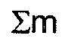 (1, 3, 4, 6) and we have to implement it by using PAL. It is as shown:

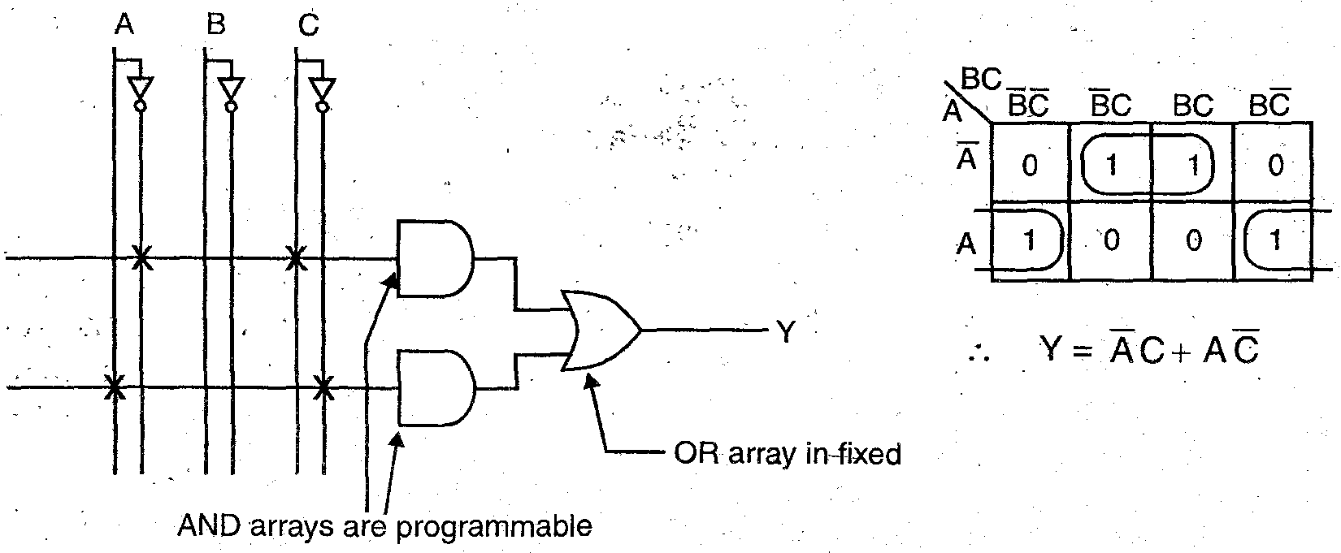

Q. Draw the block diagram of PLA logic device.
Ans.
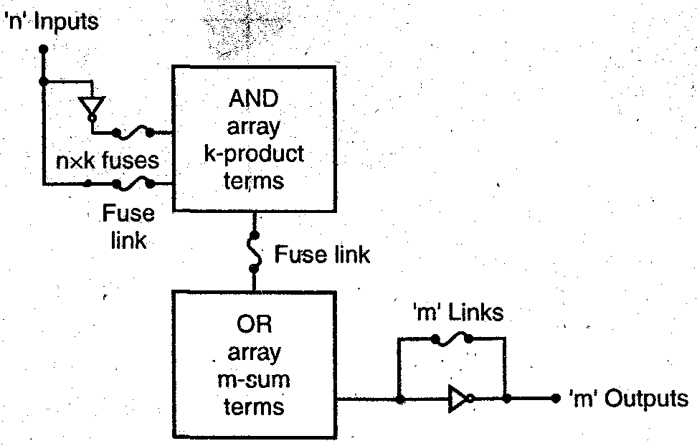

Q . Implement the Boolean function using PAL.
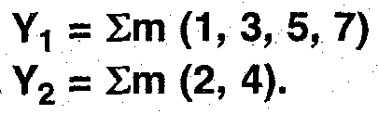
Ans. Let the input variables are A, B and C. The K-map minimization is as shown:
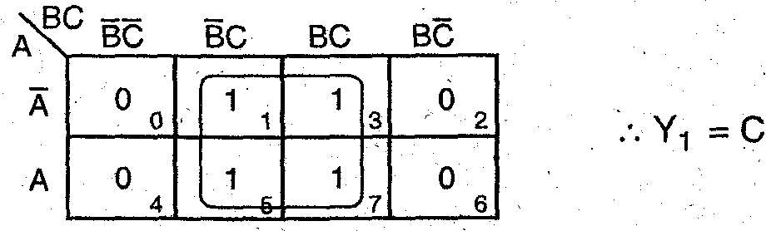
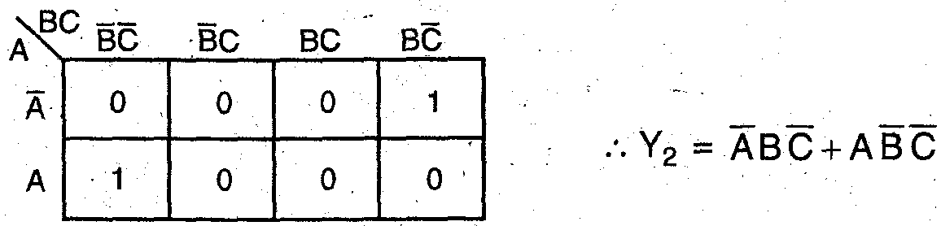
Implementation using PAL:
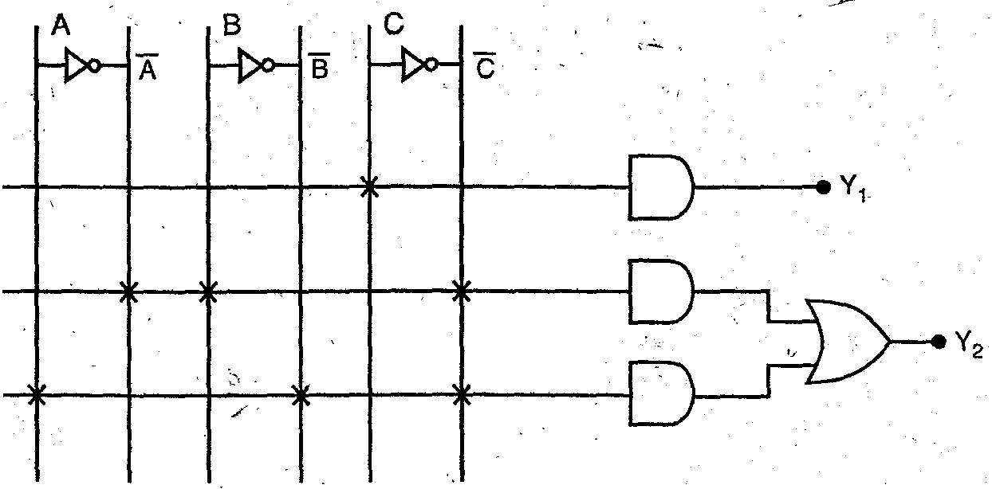

Q. Describe with diagram internal architecture of PLA
Ans PLA is Programmable Logic Array. It is used where the number of don’t care conditions are excessive. In PLA’s both AND and OR arrays are programmable. The AND and OR gates are fixed for any PLA chip. It depends on the number of inputs and outputs of PLA.
Let us take an example of Half Adder to illustrate the diagram internal architecture of PLA:
Truth Table of Half Adder:
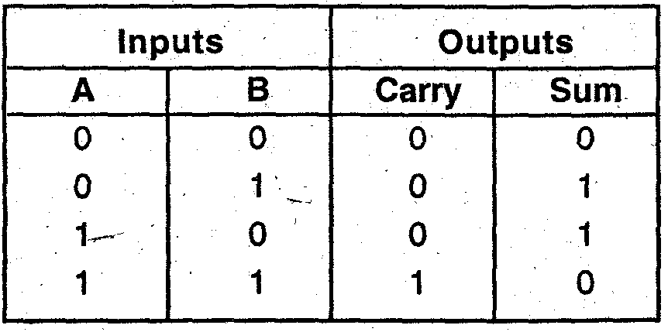
Thus, carry = A B and sum = 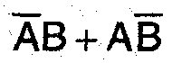
Implementation of Half Adder using PLA is as shown:
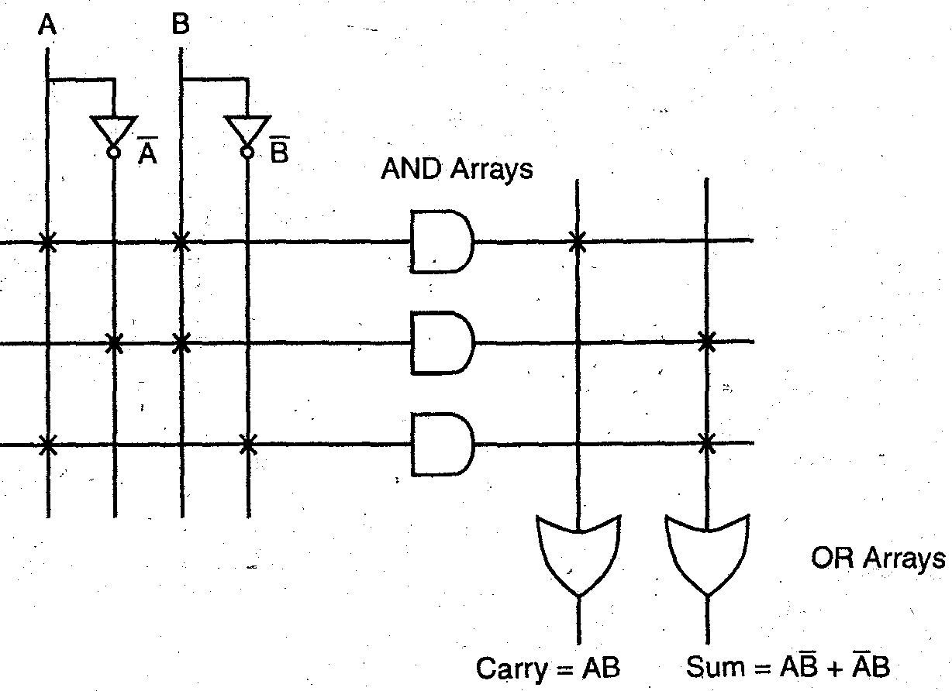

Q. Design half adder circuit using PLA.
Ans. Truth table of Half Adder circuit is:
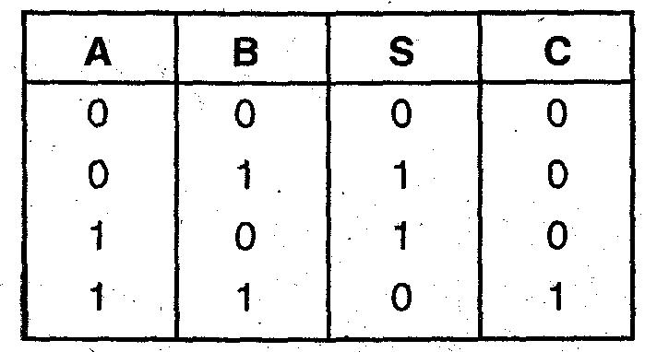
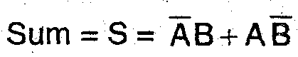
Carry = C = AB.
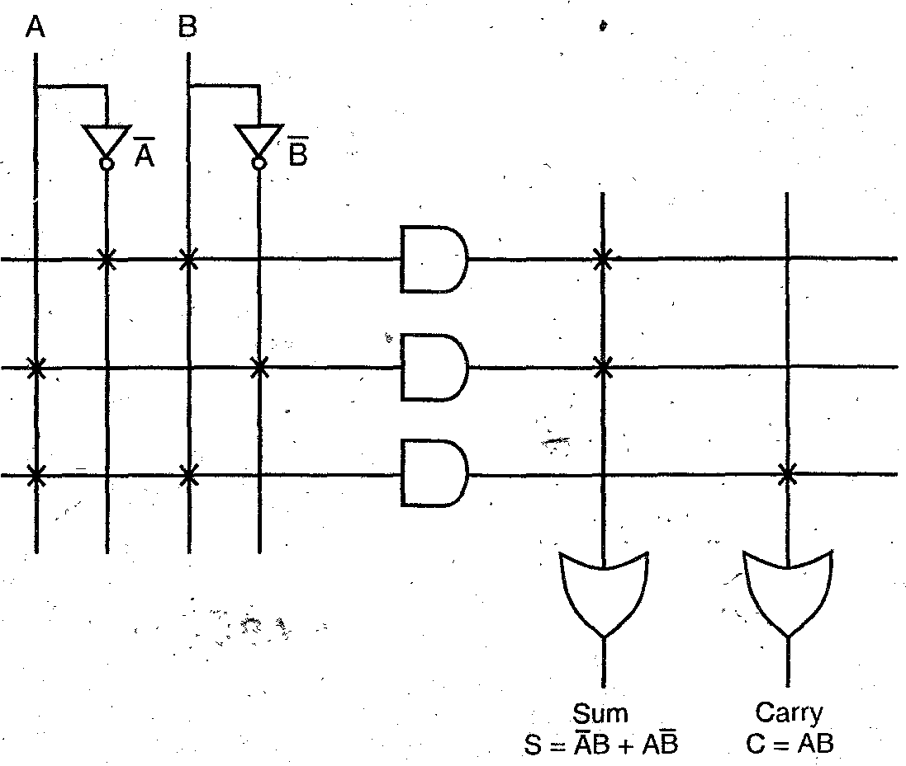
Q. Explain the role of PAL and PLA in digital design.
Ans. PAL: It is called programmable array logic . It make use of AND array only as a programmable but OR array is fixed.
PLA: It is called programmable logic array. Its AND or OR array both are programmable. Both PAL and PLA are used for memory purposes.

Q 12. What is the difference between PAL and PLA?
Ans.
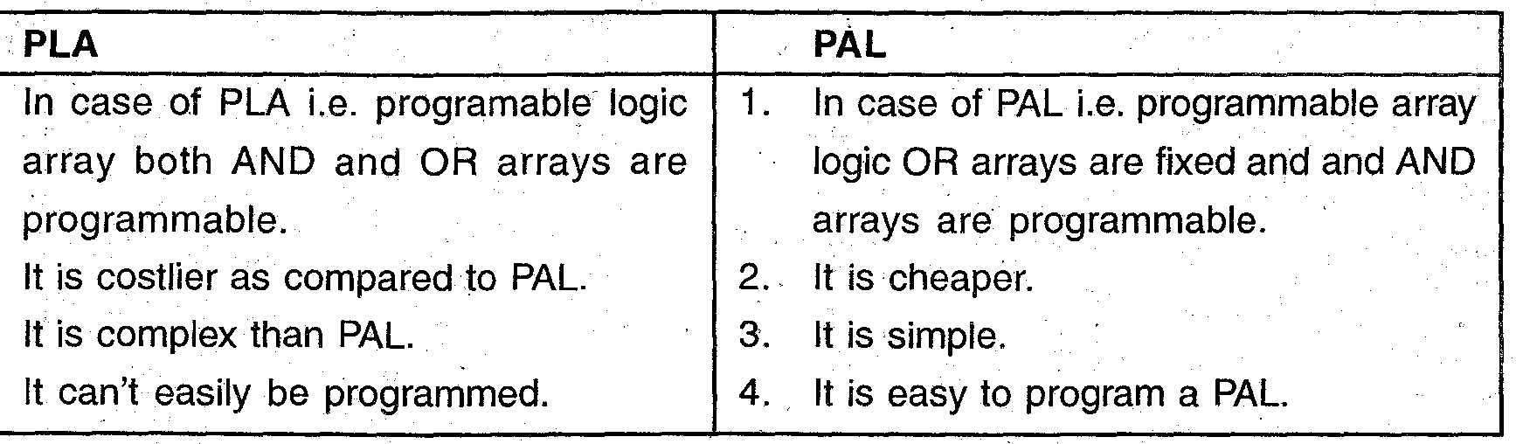

Q. Where do we use PLA’s?
Ans.
1. Combinational circuits can be implemented using PLA’s
2. Sequential circuits can be implemented using PLA’s.
3. In sequential circuits implementation flip-flops and buffers are used at output stage with PLA devices while in combinational circuits only buffers are used.
4. Compact circuits can be built using PLA’s, which covers less space.

